**Bridging Cultures: Launching a Live AI Translation Platform in South Korea**

Introduction to Global Marketing 630

By: Brian, Matt, Aaron Fore, Samarpan (Group 9)

Table of Contents

Introduction ..................................................................3

Buyers Expectations ......................................................3

Market Segment Strategies ...........................................4

Business Nuances ..........................................................7

Competition ...................................................................8

Environmental Climate ..................................................10

Opportunities .................................................................11

Market Research ............................................................12

Competition Analysis ......................................................12

Scalability ........................................................................12

Emerging Tech / Strategies .............................................13

Scope ...............................................................................13

Integration of Platforms ..................................................13

Market Entry ....................................................................14

Promotion Decisions ........................................................19

Expansion .........................................................................19

Conclusion ........................................................................20

**Introduction**

In an increasingly telecommunicated world, the need for effective and efficient communication is ever-growing. However, the diversity in languages and cultures provides significant barriers to seamless interactions, hindering effective communication and impeding meaningful relations. As a U.S.-based company, TranslatePRO is committed to breaking down these barriers by creating a cutting-edge solution and revolutionizing the communication landscape. This solution is to integrate the technology into existing devices such as phones, TVs, Laptops, etc. Our software is built to eliminate linguistic barriers and foster inclusivity. Through AI generation our software translates conversations seamlessly while capturing the essence of the subtleties of language ensuring that the users can communicate authentically and effectively whether it is in a formal setting or while having an informal conversation.

**Buyers Expectations**

Navigating the South Korean market is similar to any other market expectations and realizing what needs/wants must be satisfied with a purchase. South Korean consumers rely heavily on online sources to compare and contrast products. Consumers explore various platforms to gather information through reviews on the reliability, functionality, pricing models, and user experiences. Outside of individual research, consumers use word of mouth and the credibility of a company to make a purchase decision. Upon purchasing a product there is a trial period in which the consumer uses the product and figures out how it best fits their needs and provides the solutions to their problems.

Through Live AI Translation, TranslatePRO can provide solutions and navigate the language barrier landscape. South Korea has a multitude of dialects and a plethora of external languages spoken in the country. Throughout the ever-growing landscape of informal conversations and business needs, people need solutions to mitigate language barriers while still holding the authenticity of context within a conversation. This solution has been integrated within TranslatePRO’s platform to effectively translate a conversation based on the selected language and be able to emulate the verbal context of the conversation such as using inflections through AI-generated technology.

**Market Segmentation Strategies for TranslatePRO in the South Korean Market**

*User Demographics:*

In targeting the South Korean market, TranslatePRO should first consider diverse user demographics. With a rising interest in international travel and language learning, individual users may seek TranslatePRO for personal communication and language acquisition. Additionally, businesses, particularly in export-oriented industries like technology and manufacturing, represent a substantial user segment. Customizing features and marketing strategies to meet the specific needs of these user groups is essential for successful market penetration.

*Industry Verticals:*

South Korea's varied economic landscape requires TranslatePRO to adapt to different industry verticals. For instance, technology firms may demand accurate translation of technical documents, while the entertainment industry may require features for subtitling and script translation. By tailoring TranslatePRO to address the unique challenges of each industry, the tool can position itself as a valuable asset for businesses across various sectors.

*Regional Considerations:*

Acknowledging regional variations within South Korea is crucial for TranslatePRO's success. The economic and cultural hub, Seoul, may have distinct demands compared to other regions. Adapting the tool to seamlessly integrate with linguistic and cultural nuances of different South Korean regions, while considering the prevalence of English in business communication, ensures wider acceptance and relevance.*:*

TranslatePRO's success in the South Korean market relies on a targeted approach to market segmentation. By understanding and catering to the specific preferences of individual users, addressing industry-specific needs, and adapting to regional variations, TranslatePRO can position itself as an indispensable tool for personal and professional language translation in the dynamic South Korean landscape. (MarketTrac. (2024, January 23). Market Trac | LinkedIn. *LinkedIn*.)

*South Korean Market*

South Korea is a country that despite a limited domestic market of around 51 million still ranks 13th in Global GDP, and 4th of Asian Countries by GDP. However, considering the limited domestic market the country relies a lot on exporting and importing, with 36.5% of their GDP coming from exports in 2021. (Silver, 2023).

As such international business is of great importance, but as one might imagine Korea’s major trading partners in the U.S, China, Vietnam, Hong Kong, and Japan do not speak Korean in a broad sense across businesses or otherwise. Live translation services targeted towards businesses that operate internationally with a precise amount (based on primary languages spoken across Korean businesses) of very accurate and nuanced translations suitable for business and everyday life is the goal.

**Culture**

*Confucianism*

Philosophy emphasizing respect for elders and hierarchy, shapes Korean society. Age, position, and education determine status.

*Collectivism:*

Harmony and group success take precedence over individual needs. Building strong, long-term relationships is vital.

*"In-Group" Mentality*

Koreans value belonging and prioritize loyalty to family, friends, and company. Building trust before business can be crucial.

**Business Culture Nuances**

*Hierarchy and Respect*

Titles and seniority are revered. Bowing, using honorifics, and addressing superiors appropriately are essential.

*Indirect Communication*

Koreans often avoid direct confrontation and express disagreement subtly. Be patient and read between the lines.

*Decision-Making*

Processes can be slow, involving consensus building and senior approval. Patience and understanding are key.

*Saving Face*

Maintaining dignity and avoiding embarrassment are paramount. Be mindful of your actions and words.

*Gift-Giving*

It's a common practice to exchange gifts to build relationships. Research appropriate etiquette beforehand.

*Competition*

Koreans are driven and achievement-oriented. Be prepared for a fast-paced environment and demonstrate your value.

*Work Ethic*

Long working hours and dedication are expected. Punctuality and professionalism are highly valued.

*Modernity*

Despite traditional aspects, South Korea embraces technology and innovation. Be adaptable to new trends and practices.

(Hough, 2023 and Evason, 2016).

***Nature of the Competition***

While there are many competitors in the AI translation space we decided to focus on three in particular; Google, DeepL, and the Naver Cloud Platform.

Google is likely the biggest name to jump out of that list as it is the most widely used of anyone else on the list. Google boasts the ability to offer real-time translation of speech, text, and video in over 100 languages. However, Google’s translation offerings are rather general at best thus not suited for the nuances of business transactions across nations, cultures, and language barriers. (Ling Perfect, 2023).

DeepL on the other hand offers more nuanced translation services, albeit “limited” in a sense compared to Google by offering around 46 languages. However, where DeepL lacks in breadth of languages it shines more than Google in its accuracy of the languages it does offer. That’s not to say they don’t have shortcomings especially in penetrating a market such as South Korea, because their language software is primarily best for European languages. However, it still boasts more accuracy than Google in Chinese, and other Asian languages. (DeepL, 2024).

Finally, we focused on the Naver Cloud Platform and their AI translation service called Papago Cloud. Naver is a South Korean company that offers translations in 13 languages via text, with only a subset of those being offered via live speech text. (Naver, 2024). However, as one might expect Naver is good with the Korean language and by being a Korean company they have a better foothold on the market.

Based on our analysis of the competition we positioned them based on how we positioned the competitors based on the amount of languages they offer (narrow/broad) and the accuracy at which they deliver those languages (low/high). Furthermore, we positioned ourselves where we envision the software, which is to say we’d like to offer high accuracy with a broad, but more focused amount of languages to offer.

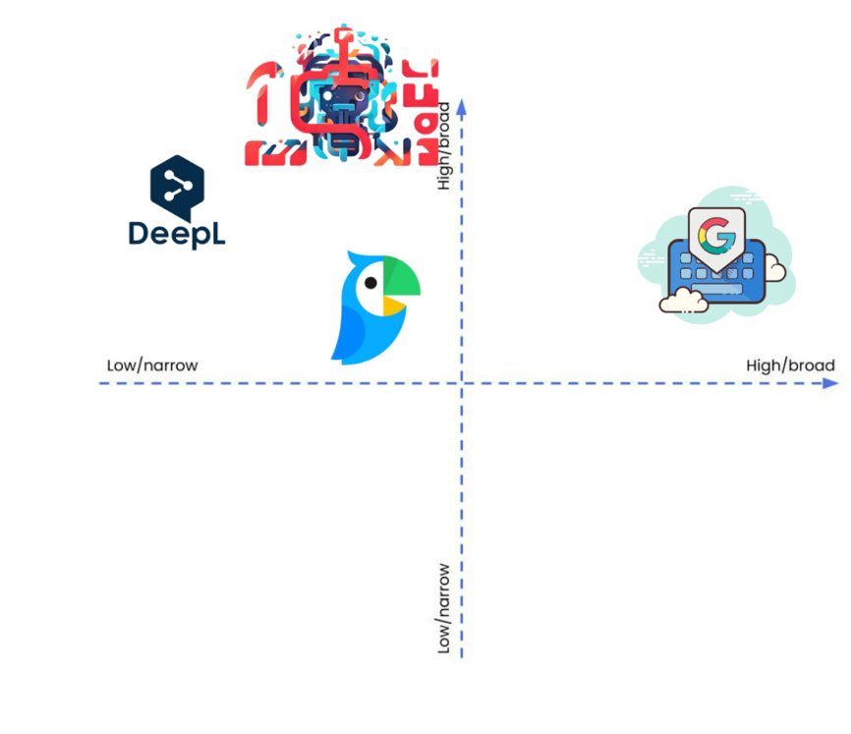

**Environmental climate**

*Market Conditions*

TranslatePRO's success hinges on its ability to navigate market conditions. Economic factors, demand for translation services, and competition collectively define the market climate. A growing global need for cross-cultural communication and expanding international business activities create a favorable market environment for TranslatePRO.

*Technological Landscape*

TranslatePRO operates in a landscape characterized by rapid technological advancements. The technological climate directly influences the tool's functionality and competitiveness. Staying abreast of AI, machine learning, and natural language processing trends is imperative for TranslatePRO to continuously enhance its capabilities and maintain relevance.

*User Preferences and Expectations*

User preferences and expectations shape the user climate for TranslatePRO. Adapting to evolving user needs, collecting feedback, and providing user-friendly interfaces contribute to positive user experiences. The tool's ability to meet diverse user expectations enhances its market positioning.

*Environmental Sustainability*

In the broader context of corporate responsibility, TranslatePRO operates in a climate where environmental sustainability considerations play a role. Adhering to sustainable practices enhances the tool's reputation and aligns it with the values of environmentally conscious users.

**Expansion of opportunities**

Growing prospects in South Korea for AI real-time translation provide an exciting path for technology advancement and intercultural dialogue.

### **Market Research**

In order to determine what features customers value in AI translation tools, how much they are prepared to pay for such services, and what factors influence their purchasing decisions, market research, surveys, interviews, and user data analysis are all necessary to understand user preferences and willingness to pay.

### **Competitor Analysis**

Assessing rival products' advantages, disadvantages, and special selling features is helpful. AI translation solutions may be positioned in the market more successfully and possible areas for differentiation and competitive advantage can be found by evaluating pricing and distribution methods.

### **Scalability and Expansion**

The ability of AI translation systems to effectively manage growing data quantities and user counts is a key component of scalability assessment. Target market identification, partnership potential analysis, and the creation of strategies to successfully enter new markets or geographic areas are all part of developing expansion strategies.

### **Emerging Technologies and Trends**

Maintaining a current knowledge of AI, NLP, and translation technology is essential to tracking market trends. Innovation in AI translation solutions can be fostered and strategic decision-making informed by keeping a watch on new trends like multimodal translation, real-time collaboration tools, and AI-driven content development.

**Scope**

**Strategic Partnerships and Collaborations**

AI translation solutions can be made more capable and more accessible by forming strategic relationships with content creators, technology companies, and language service providers. Working together with industry stakeholders provides reciprocal growth and innovation by providing access to complementary resources, experience, and market insights.

### **Integration with Existing Platforms**

The user experience and usefulness of current platforms, such messaging applications, social networking sites, and e-commerce websites, are improved and expanded when AI translation capabilities are integrated with them. Adoption and engagement are increased by seamless integration, which makes it simple for consumers to receive translation services in settings they are acquainted with.

### ***Ethical Considerations***

Ensuring data security, protecting user privacy, and reducing biases in AI translation systems are all part of addressing ethical issues. Users' trust is increased when moral principles and legal requirements are upheld, which encourages the responsible use of AI translation tools.

### ***Quality Assurance and Localization***

Providing excellent user experiences depends on translations being accurate, fluid, and culturally relevant. AI translation solutions are more relevant and widely accepted when they are implemented with strong quality assurance procedures, linguistic validation, and localized translations that take cultural quirks and dialects into account.

**Market Entry**

For TranslatePRO's entry into the Seoul market in South Korea, distribution decisions must be finely tuned to match the unique characteristics of the local landscape. Providing solutions to the needed language and dialect translation landscape and distributing the platform throughout the tech industry will be essential to integrating TranslatePRO as a leading language translation product. While analyzing the competitive landscape the company will promote the platform on various e-commerce sites as well as partner with public figures such as influencers.

Strategic movement into integrating the platform can also be promoted through academia and local businesses to garner the attention of larger and more high-level corporations. This examination delves into distribution intensity, channels, and the selection of wholesalers and retailers, offering insights into strategically positioning TranslatePRO for optimal market reach and success in Seoul.

*Pricing decisions*

We further broke the competition by their pricing strategies as pictured in the figure below:

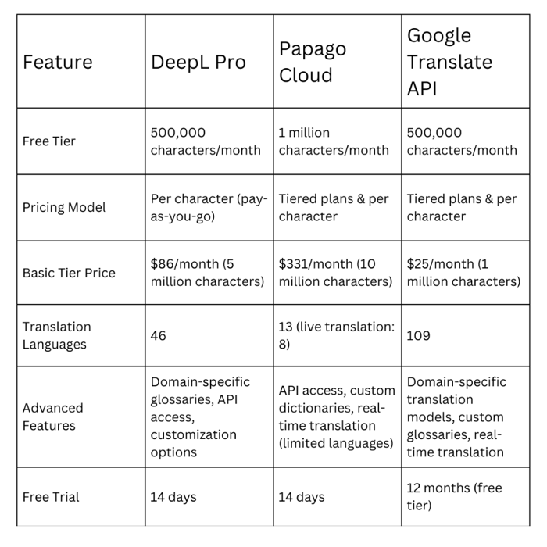

We can see that each competitor offers a free tier based on characters per month, with Papago offering double that of DeepL Pro and the Google Translate API. Our strategy would be to go beyond this to entice new consumers to our platform by offering 1.5 million characters per month on our free tier.

While DeepL offers a pay-as-you-go model, the other two prefer tiered plans. Though per character strategies persist among all three either way. At a basic level we see DeepL offering 5 million characters for around $86 a month. Google on the other hand offers just 1 million characters at their base level but comes in very cheap at $25 per month. Papago is the most expensive at over $330 a month while offering 10 million characters.

Based on competitor analysis our pricing strategy would offer 1.5 million characters per month on the free tier while offering tiered models that would start on a base tier at $100 per month for 10 million characters while offering around 20 languages specifically targeted towards countries Korean’s do international business with most.

*Distribution Intensity*

In the Seoul market, TranslatePRO should adopt a selective distribution approach. Given the cultural emphasis on personalized service and the diverse linguistic needs within the city, strategically choosing outlets based on specific criteria would align well with consumer preferences. Seoul's dynamic and tech-savvy population may appreciate the exclusivity that comes with selectively distributing TranslatePRO through outlets catering to language enthusiasts, educational institutions, and technology hubs.

*Distribution Channels*

Direct distribution should be a primary focus for TranslatePRO in Seoul. Establishing company-owned outlets or partnering with existing technology-focused stores can provide direct access to consumers, allowing for a more personalized and controlled customer experience. Additionally, online platforms and partnerships with popular e-commerce sites can cater to Seoul's digitally connected population.

*Types of Wholesalers/Retailers*

Incorporating local specialty retailers into TranslatePRO's distribution strategy can be advantageous. Collaborating with bookstores, language learning centers, and technology retailers aligns the product with the specific needs and preferences of the Seoul market. Engaging with these types of retailers can also provide opportunities for localized marketing and promotional activities.

*Strategic Considerations*

Understanding the cultural nuances of Seoul is crucial for TranslatePRO's distribution strategy. Considerations such as the importance of education, the technological landscape, and the preferences of the local consumer base should inform decision-making. Strategic alliances with educational institutions and partnerships with tech-focused retailers can enhance the product's visibility and appeal.

*Challenges and Opportunities*

Challenges in the Seoul market may include competition from local language learning solutions and navigating the intricacies of cultural expectations. However, by embracing the opportunities to collaborate with local influencers, educational institutions, and leveraging the city's tech-savvy environment, TranslatePRO can position itself as a reliable and culturally attuned language translation solution.

**Promotion decisions**

We aim to launch focused advertising on Naver, KakaoTalk, and Facebook, reaching specific audience segments in South Korea. We’ll partner with influential figures to amplify the reach. We aim to use a tech-savvy engagement strategy by leveraging the high internet penetration by promoting on top tech websites and targeting advertising of content across various social media platforms and streaming services.

*Embrace diversity*

Support seamless dialect recognition to cater to diverse audiences.

*Cultivate satisfaction*

Engage by understanding and fulfilling cultural wants and needs.

*Use Adaptive learning*

Continuously learn and adapt our strategy based on real-time data and audience feedback.

**Furthermore, we will highlight**

*Localization Oasis*

Korean language optimization: Ensure platform interfaces and content seamlessly support Hangul characters and reflect cultural norms for a familiar and engaging experience.

*Dialect Diversity*

Support seamless dialect recognition: Cater to regional variations in speech for wider reach and deeper connections.

**Conclusion**

TranslatePRO stands at the forefront of revolutionizing global communication with its cutting-edge Live AI translation platform. As a U.S. - based company, we are committed to eliminating language barriers regardless of informal or formal need by integrating the system into all electronic devices. By providing innovated processes in distribution and channeling selected markets TranslatePRO dedicates itself to supporting solutions to keep authenticity alive through AI-generated talk-to-text conversations.

**References**

Bujanowicz, M. (n.d.). 7 Challenges You See in Translation to Korean Language.<https://www.atltranslate.com/blog/challenges-translation-to-korean>

DeepL. (2024). DeepL. <https://www.deepl.com/whydeepl>

Evason, N. (2016, December 12). South Korean Culture - Business Culture. Cultural Atlas. Retrieved from<https://culturalatlas.sbs.com.au/south-korean-culture/south-korean-culture-business-culture>

Hough, M. (2022). Business Culture in South Korea. Global Business Culture. Retrieved from<https://www.globalbusinessculture.com/cultural-awareness/business-culture-in-south-korea/>

LingPerfect. (2023, October 01). How Accurate Is Google Translate?<https://lptranslations.com/learn/how-accurate-is-google-translate/>

MarketTrac. (2024, January 23). Market Trac | LinkedIn. LinkedIn. <https://www.linkedin.com/company/market-trac?trk=article-ssr-frontend-pulse_publisher-author-card>

Naver. (2024). Naver. From <https://www.ncloud.com/product/aiService/papagoTranslation> Bujanowicz, M. (n.d.). *7 Challenges You See in Translation to Korean Language*.

Naver. (2024). Naver. <https://www.ncloud.com/product/aiService/papagoTranslation>

Silver, C. (2023). The Top 25 Economies in the World. Investopedia. Retrieved from: <https://www.investopedia.com/insights/worlds-top-economies/#toc-11-brazil>

<https://www.atltranslate.com/blog/challenges-translation-to-korean>

South Korea: Reaching the consumer. Reaching the South Korean consumer - Santandertrade.com.(n.d.). <https://santandertrade.com/en/portal/analyse-markets/south-korea/reaching-the-consumers>